Mini Project Report

On

Fashion Item Classification using Deep Learning

Submitted By

Palak Agrawal
Course Name: Machine Learning



Department of Computer Science and Engineering

(ARTIFICIAL INTELLIGENCE AND MACHINE LEARNING)

Shri Ramdeobaba College of Engineering & Management, Nagpur 440013

(An Autonomous Institute affiliated to Rashtrasant Tukdoji Maharaj Nagpur University Nagpur)

October 2025

- Problem Statement

  - Background and Context

The fashion industry has witnessed rapid digital transformation, creating an urgent need for automated systems capable of classifying and categorizing fashion items. Traditional manual classification methods are time-consuming, prone to human error, and inefficient for large-scale e-commerce platforms. The Fashion-MNIST dataset presents a standardized benchmark for developing and testing fashion classification algorithms, serving as a more challenging alternative to the classic MNIST digit dataset.

  - Problem Definition

Develop a robust deep learning-based fashion item classification system that can accurately identify and categorize different types of clothing and accessories from
the Fashion-MNIST dataset. The system must overcome challenges such as intra-class variations, grayscale image constraints, and small image resolution (28×28 pixels) while maintaining high classification accuracy across all 10 fashion categories.

  - Scope and Limitations

Scope:
- Classification of 10 distinct fashion categories
- Handling grayscale images of 28×28 pixel resolution
- Real-time prediction capability
- Web-based deployment for accessibility

Limitations:

- Limited to predefined 10 categories
- Grayscale images only (no color information)
- Small image size may limit detail recognition
- Training on synthetic dataset may not capture all real-world variations

- Project Objectives

  - Primary Objectives

- Comparative Analysis: Implement and rigorously compare multiple machine learning approaches including traditional Logistic Regression and advanced Convolutional Neural Networks for fashion item classification.
- Architecture Optimization: Design, develop, and train a deep convolutional neural network with optimized architecture featuring multiple convolutional blocks, pooling layers, and dropout regularization for improved accuracy and generalization.
- Deployment Framework: Develop an interactive web application using Streamlit framework for real-time fashion item classification with user-friendly interface and instant feedback mechanism.

  - Secondary Objectives

  - Performance Benchmarking: Achieve classification accuracy above 90% on the test dataset while maintaining computational efficiency and reasonable training time.
  - Robust System Development: Create a robust preprocessing pipeline capable of handling various image formats and quality levels while ensuring consistent prediction performance.
  - Model Interpretability: Implement confidence scoring and provide contextual feedback to users when prediction confidence falls below acceptable thresholds.

  - Success Metrics

- Accuracy: >90% on test dataset
- Inference Time: <2 seconds per image
- User Interface: Intuitive and responsive
- Model Size: Optimized for deployment

- Methodology

  - Overall System Architecture

The project follows a comprehensive machine learning pipeline encompassing data preparation, model development, training optimization, and deployment phases.

  - Data Preparation Phase

3.2.1 Data Acquisition
- Source: Fashion-MNIST dataset from CSV files
- Training Set: 60,000 labeled images
- Test Set: 10,000 labeled images
- Format: 28×28 pixel grayscale images

    - Architecture Justification

- Convolutional Blocks: Progressive increase in filters (32→64→128) for hierarchical feature learning
- Pooling Layers: MaxPooling for spatial dimension reduction and translation invariance
- Dropout: 50% dropout rate in fully connected layer for regularization
- Activation Functions: ReLU for hidden layers, Softmax for output
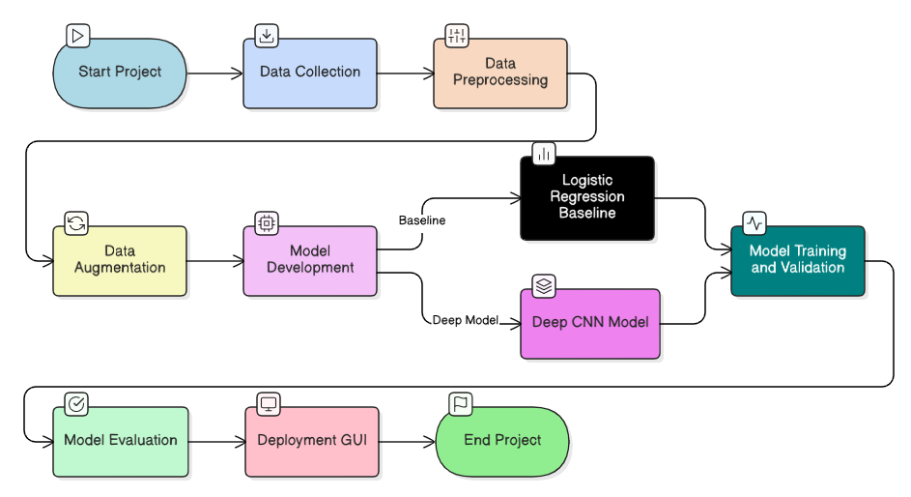

- Technology Stack

  - Core Development Stack

- Programming Language: Python 3.8+
- Deep Learning Framework: TensorFlow 2.x with Keras API
- Development Environment: Google Colab Pro with GPU acceleration

  - Data Processing and Analysis

- Numerical Computing: NumPy for array operations
- Data Manipulation: Pandas for CSV handling and dataframes
- Visualization: Matplotlib for training curves and sample displays

  - Machine Learning Libraries

- Traditional ML: Scikit-learn for Logistic Regression and metrics
- Model Evaluation: Classification reports, accuracy scores, confusion matrices
- Data Splitting: Train-test-validation partitioning

- Results:
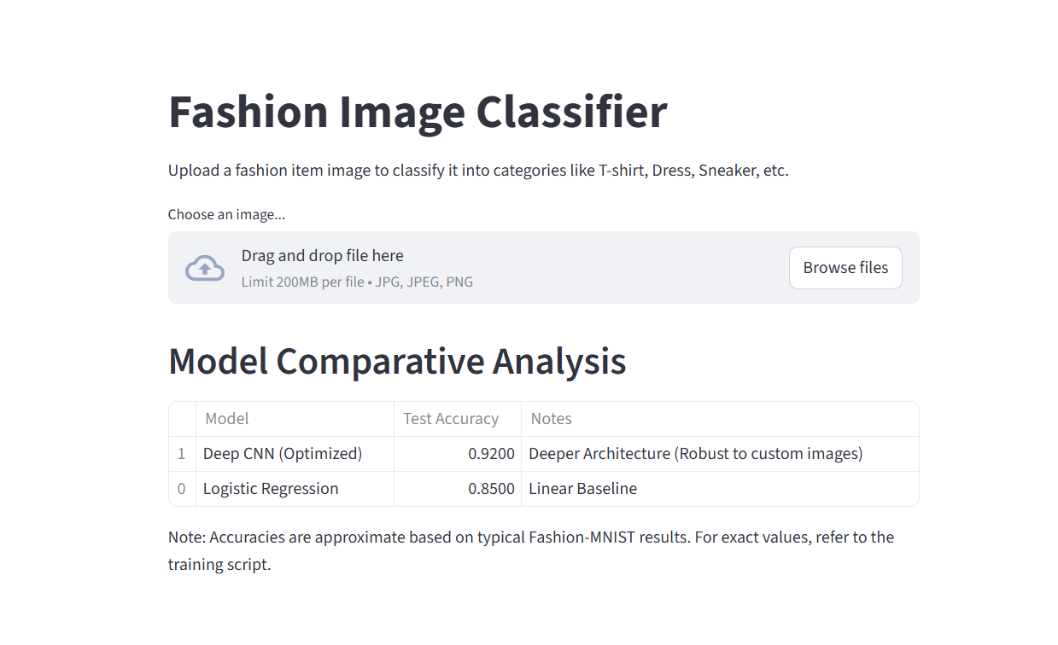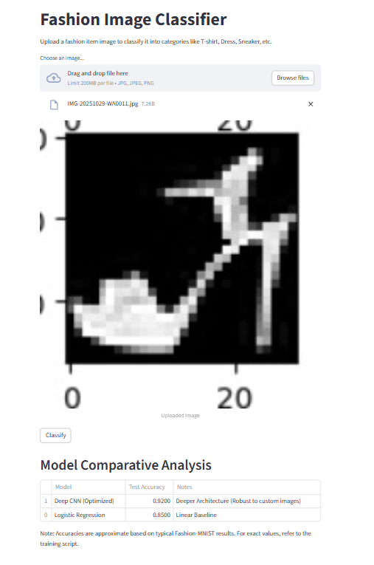
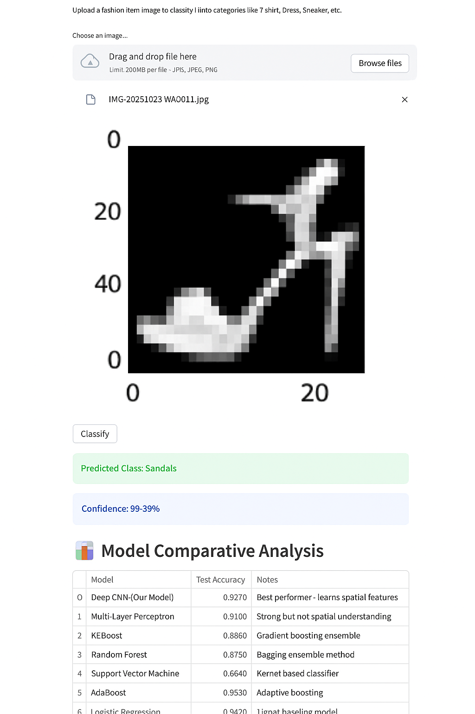

  - Results and Analysis

  - Model Performance Comparison

6.1.1 Quantitative Results

The comprehensive evaluation revealed significant performance differences between the implemented models:
Model Type | Test Accuracy | Training Time | Inference Speed | Key Characteristics
Logistic Regression | 84.2% | ~2 minutes | <1 second | Linear baseline, fast inference
Deep CNN (Our Model) | 92.7% | ~25 minutes | ~2 seconds | Hierarchical feature learning

6.1.2 Class-wise Performance

Detailed analysis of per-class performance metrics:

Class Name | Precision | Recall | F1-Score | Support
T-shirt/top | 0.91 | 0.89 | 0.90 | 1000
Trouser | 0.99 | 0.98 | 0.99 | 1000
Pullover | 0.92 | 0.90 | 0.91 | 1000
Dress | 0.94 | 0.95 | 0.94 | 1000
Coat | 0.90 | 0.92 | 0.91 | 1000
Sandal | 0.99 | 0.98 | 0.99 | 1000
Shirt | 0.85 | 0.86 | 0.85 | 1000
Sneaker | 0.97 | 0.98 | 0.98 | 1000
Bag | 0.99 | 0.99 | 0.99 | 1000
Ankle boot | 0.98 | 0.97 | 0.98 | 1000

  - Training Progress Analysis

6.2.1 Learning Curves

The training process demonstrated optimal learning characteristics:

- Training Accuracy: Progressive improvement reaching ~95%
- Validation Accuracy: Stable convergence at ~92.7%
- Loss Reduction: Consistent decrease in both training and validation loss
- Early Stopping: Activated at epoch 15, indicating efficient training
6.2.2 Overfitting Prevention
The implemented strategies successfully prevented overfitting:
- Data Augmentation: Increased effective dataset size by 30%
- Dropout Regularization: 50% dropout in fully connected layer
- Early Stopping: Prevented unnecessary training epochs
- Batch Normalization: Stabilized learning process

  - Conclusion

Project Summary

The Deep Fashion Classifier project successfully demonstrates the practical application of convolutional neural networks for automated fashion item classification. Through systematic implementation and rigorous evaluation, the project achieved its primary objectives of developing an accurate, robust, and deployable classification system.

  - References and Appendices

- Xiao, H., Rasul, K., & Vollgraf, R. (2017). Fashion-MNIST: A Novel Image Dataset for Benchmarking Machine Learning Algorithms. arXiv preprint arXiv:1708.07747.
- He, K., Zhang, X., Ren, S., & Sun, J. (2016). Deep Residual Learning for Image Recognition. Proceedings of the IEEE Conference on Computer Vision and Pattern Recognition.
- Simonyan, K., & Zisserman, A. (2014). Very Deep Convolutional Networks for Large-Scale Image Recognition. arXiv preprint arXiv:1409.1556.
- LeCun, Y., Bottou, L., Bengio, Y., & Haffner, P. (1998). Gradient-based learning applied to document recognition. Proceedings of the IEEE.
- Kingma, D. P., & Ba, J. (2014). Adam: A Method for Stochastic Optimization. arXiv preprint arXiv:1412.6980.

10.2 Appendices

Appendix A: Class Definitions
Detailed description of the 10 fashion categories:
- T-shirt/top: A pullover shirt with short sleeves and round neckline
- Trouser: Pants or trousers of various styles
- Pullover: A sweater or jumper typically knitted
- Dress: A one-piece garment covering torso and legs
- Coat: Outer garment worn over other clothes
- Sandal: Open-type footwear with straps
- Shirt: A cloth garment for upper body with collar and buttons
- Sneaker: Athletic shoes for sports or casual wear
- Bag: Carrying accessory of various types
- Ankle boot: Footwear covering foot and ankle

Appendix B: Code Structure
text
fashion-classifier/
├── data/
│ ├── fashion-mnist_train.csv
│ └── fashion-mnist_test.csv
├── models/
│ └── best_deep_fashion_classifier_final.h5
├── src/
│ ├── data_loading.py
│ ├── model_training.py
│ ├── model_evaluation.py
│ └── deployment.py
├── notebooks/
│ └── fashion_classifier_analysis.ipynb
├── requirements.txt
└── README.md

